**Cyprus Trip Planning**

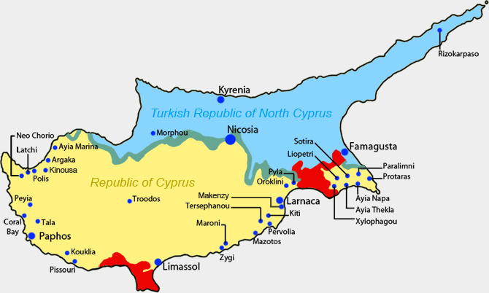

|  |
| --- |
|  |

[**https://vagrantsoftheworld.com/the-best-of-cyprus/**](https://vagrantsoftheworld.com/the-best-of-cyprus/)

[**https://www.getyourguide.com/s/?q=Nicosia&et=80646**](https://www.getyourguide.com/s/?q=Nicosia&et=80646)

[**https://www.thisbatteredsuitcase.com/what-to-do-in-nicosia/**](https://www.thisbatteredsuitcase.com/what-to-do-in-nicosia/)

[**http://www.xtremespots.com/fly-sports/paragliding/petra-tou-romiou-paphos-cyprus/**](http://www.xtremespots.com/fly-sports/paragliding/petra-tou-romiou-paphos-cyprus/)

[**https://journalistontherun.com/2018/07/08/things-to-do-in-paphos/**](https://journalistontherun.com/2018/07/08/things-to-do-in-paphos/)

[**https://www.chooseyourcyprus.com/discover-cyprus/cape-greko-national-forest-park.html**](https://www.chooseyourcyprus.com/discover-cyprus/cape-greko-national-forest-park.html)

**Passport/Visas**

* Passports should have at least six months of remaining validity. You need proof of sufficient funds and a return airline ticket. You may enter the Republic of Cyprus for up to 90 days for tourist or business purposes without a visa. For stays longer than 90 days, you will need a temporary residency visa.

**Flight Info**

* NYC/Larnaca, Mar 23, 2019 - Mar 31, 2019
* Confirmation: VM2S5B (British Airways)
* Saturday, March 23rd
  + New York (JFK), 10:55 pm → London (LHR) 9:45 am (+ 1 day, arrives March 24)
  + 2h 5m stop London (LHR)
  + London (LHR) 11:50 am → Larnaca (LCA) 6:30 pm
  + Total duration 13h 35m
* Sunday, March 31st
  + Larnaca (LCA) 2:55 pm → London (LHR) 6:00 pm
  + 1h 30m stop London (LHR)
  + London (LHR) 7:30 pm → New York (JFL) 10:30 pm
  + Total duration 14h 35m

**Cities**

* Larnaca (coastal, arrival city)
* Nicosia (capital, old city)
* Paphos (coastal & archaeological sites, more historical side of the island)
* Kyrenia (coastal, really scenic)
* Limassol (coastal, castle, promenade)
* Ayia Napa (Konnos Bay, southeast part of the island, good beaches/nightlife)

**Attractions**

* Coral Bay (bustling beach for swimming & boating) - Paphos
* Nissi Beach (year-round beach with clean blue waters) - Ayia Nappa
* Cape Greco (cliff, snorkeling, and nature) - Ayia Nappa
* Petra tou Tomiuo/Aphrodite’s Rock (legendary rock just off scenic beach) lol - Paphos
* Xs Watersports (jet skis, paragliding, etc.)
* St. Hilarion Castle
* STS Motofun (atvs on the beach)
* Vouni Panayia Winery - Paphos
* Saint Lazarus Church - Larnaca
* The Hala sultan mosque in Haspolat - Larnaca
* Old Turkish Quarter - Larnaca
* Sunrise Beach
* Tombs of the Kings - Paphos

**Airbnbs/Hotels**

* **Larnaca**: We may need two one for the beginning of our trip and one for when we leave
  + <https://www.airbnb.com/rooms/28993799?s=51> $39 per night

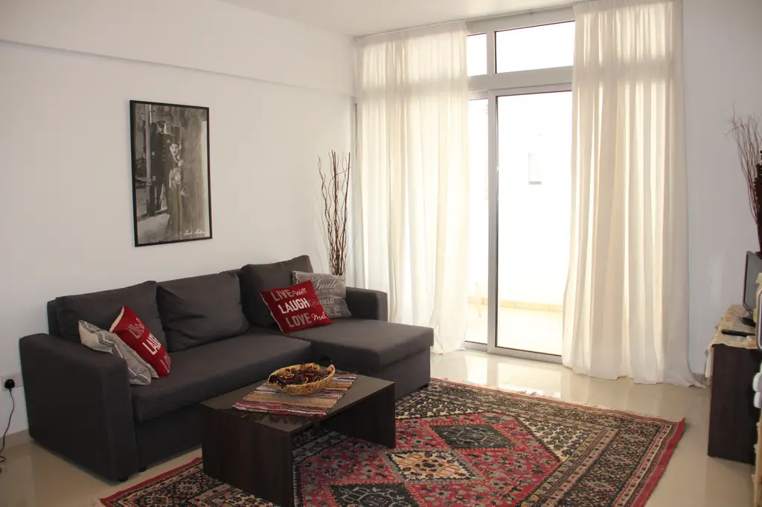

* + <https://www.airbnb.com/rooms/22912870?s=51> $64 per night

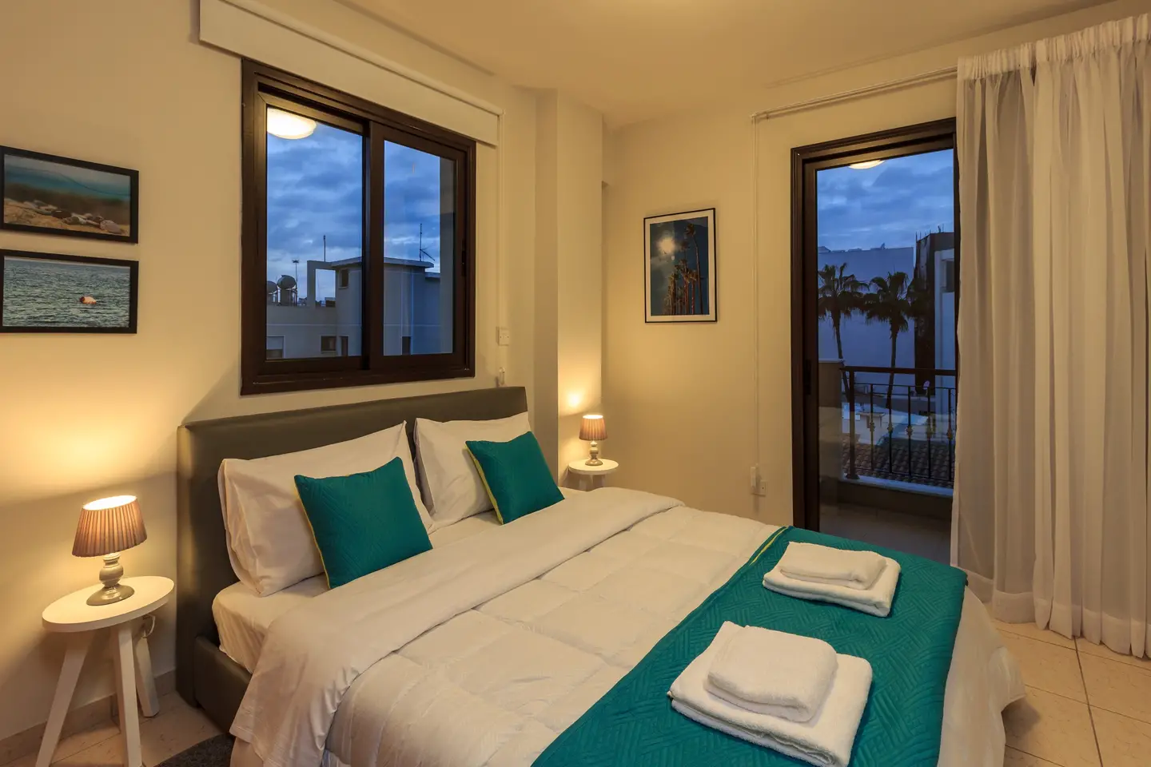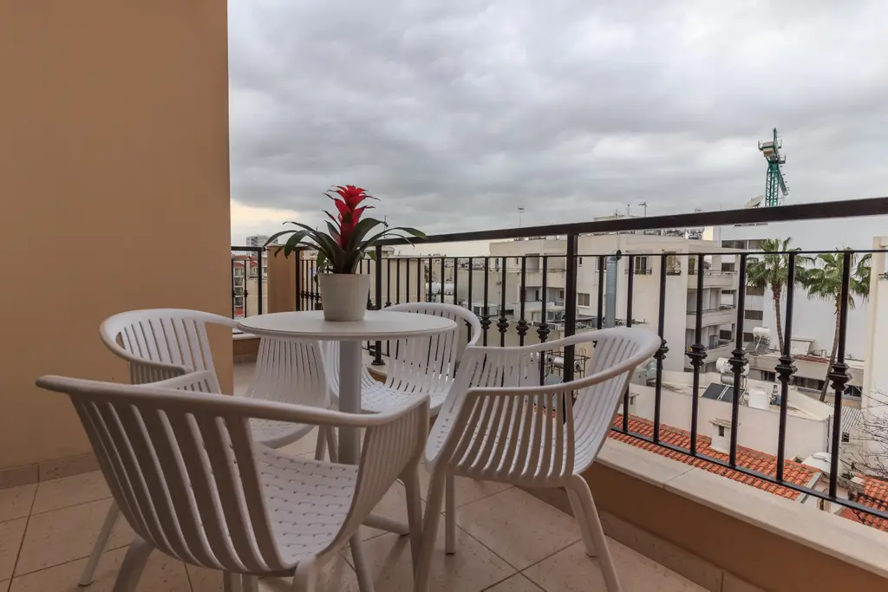

* + <https://www.airbnb.com/rooms/19184208?s=51> $68 per night (open availability)

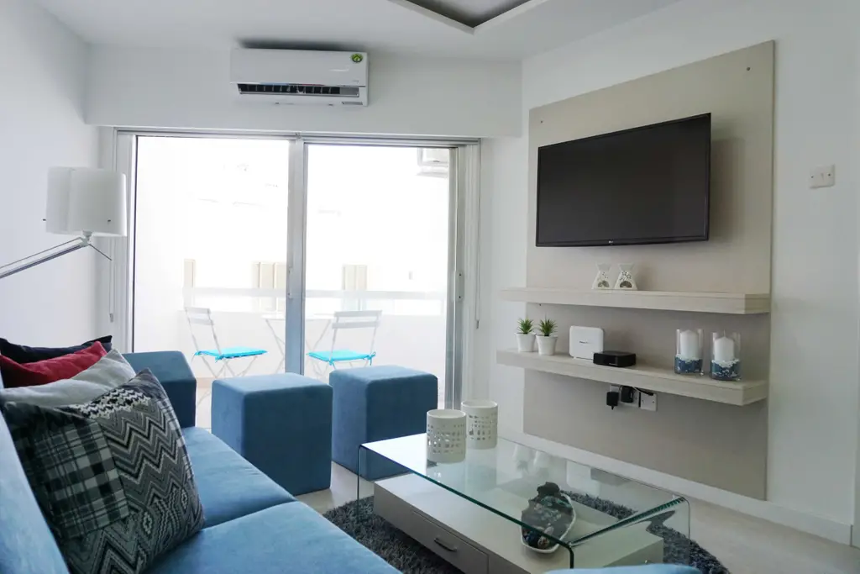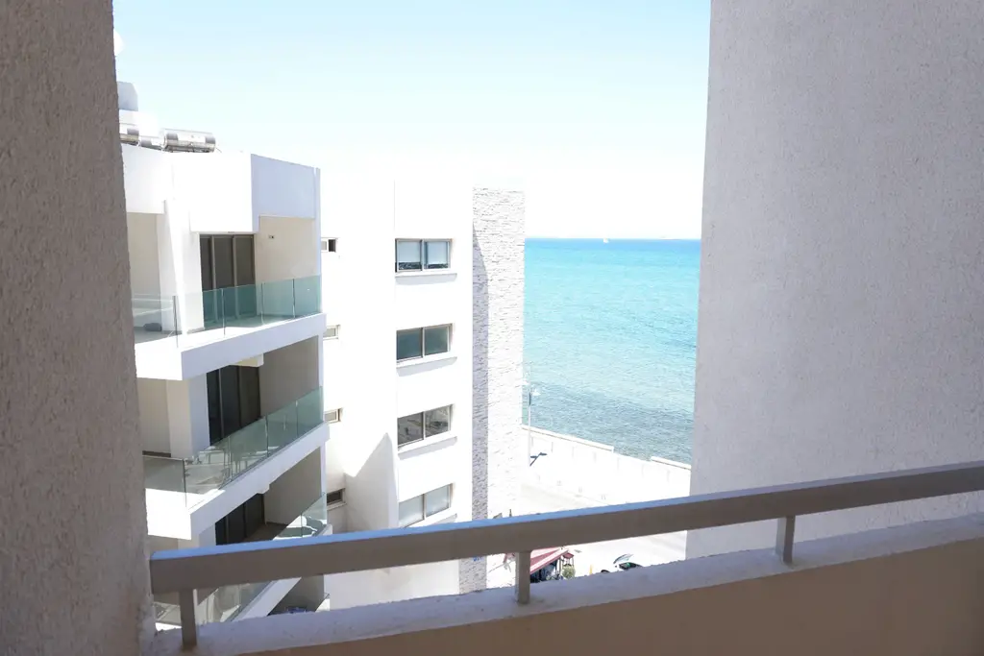

* **Paphos**
  + <https://www.airbnb.com/rooms/4329040?s=51> $46 per night (open availability)

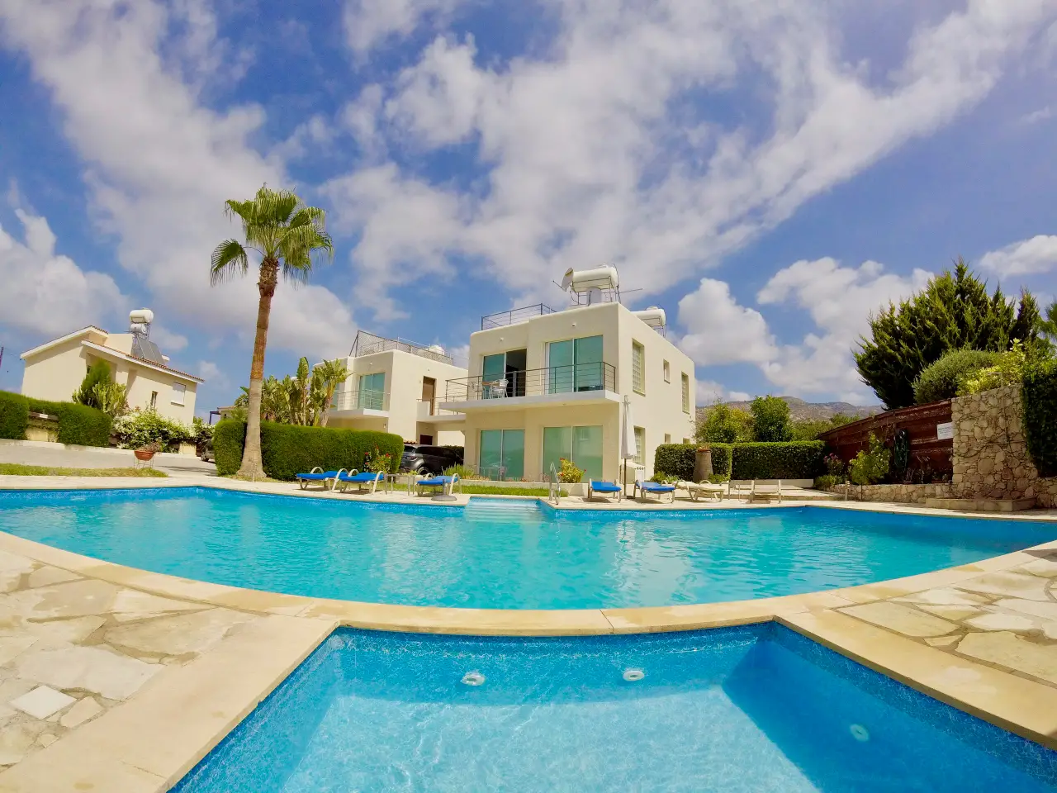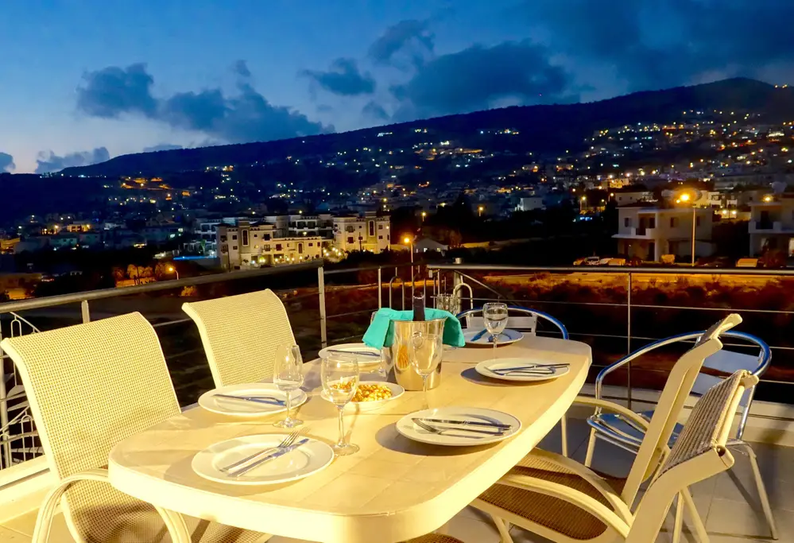

* **Nicosia**
  + <https://www.airbnb.com/rooms/1059094?s=51> $75 per night (open availability)

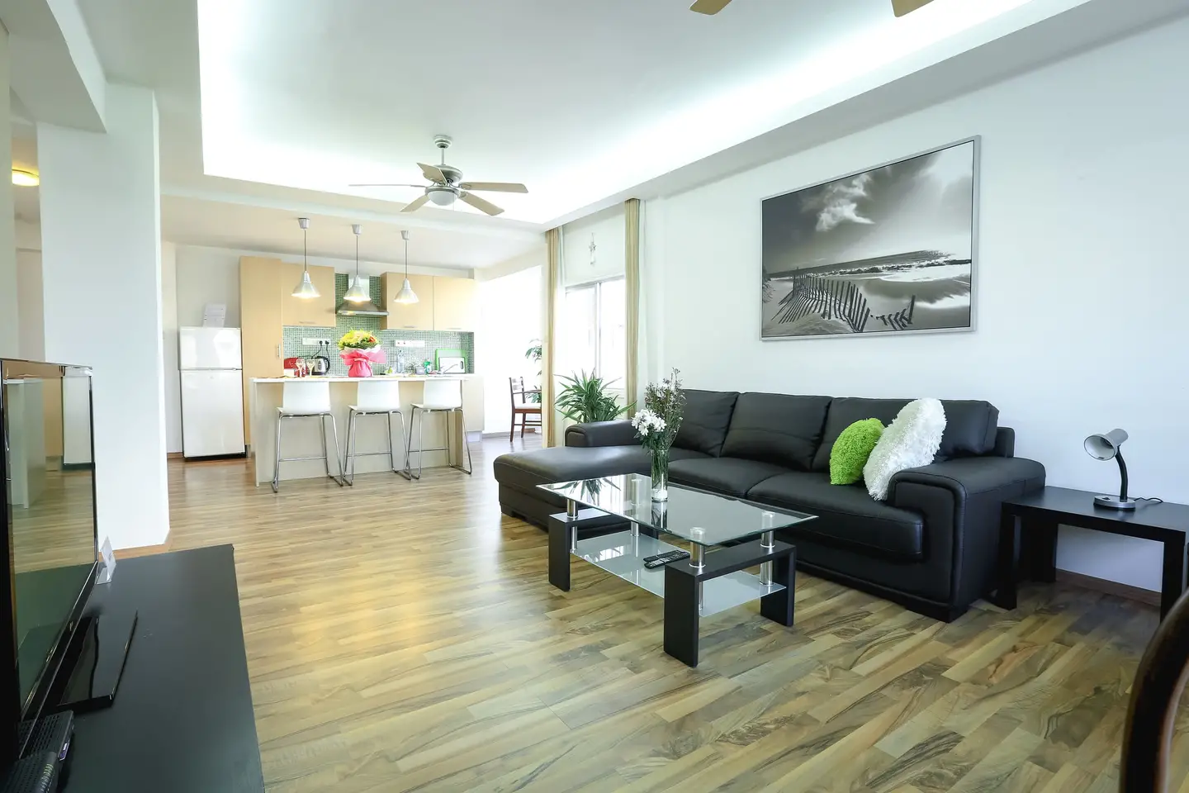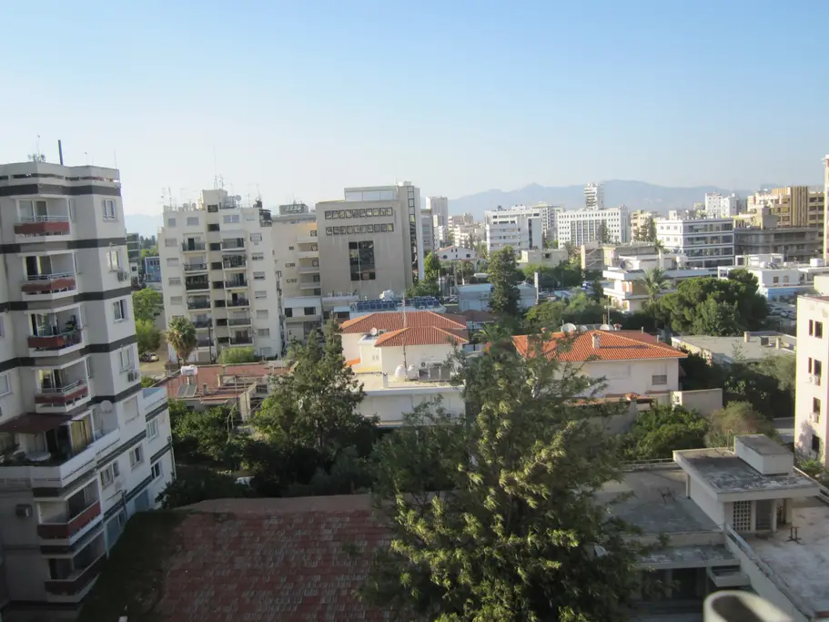

* + <https://www.airbnb.com/rooms/27817849?s=51> $81 per night (open availability)

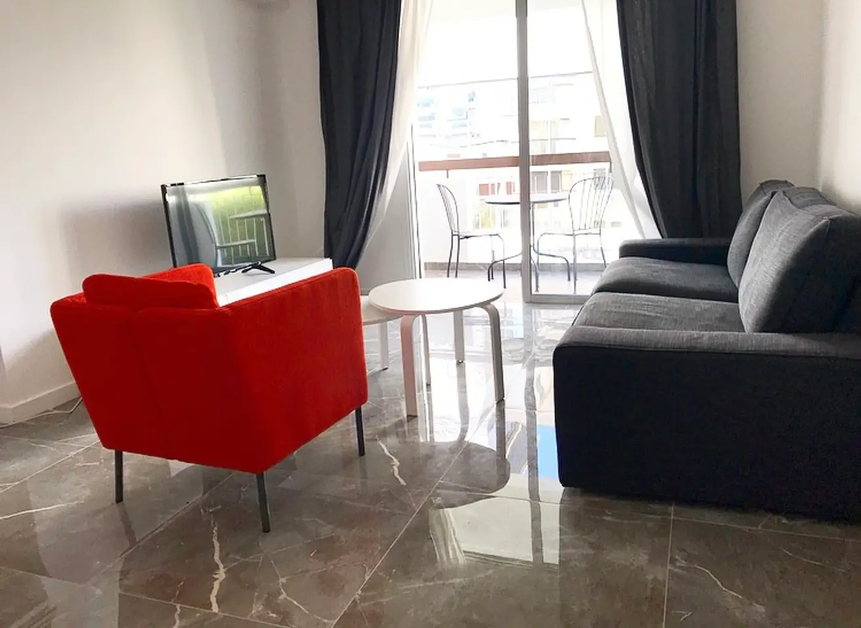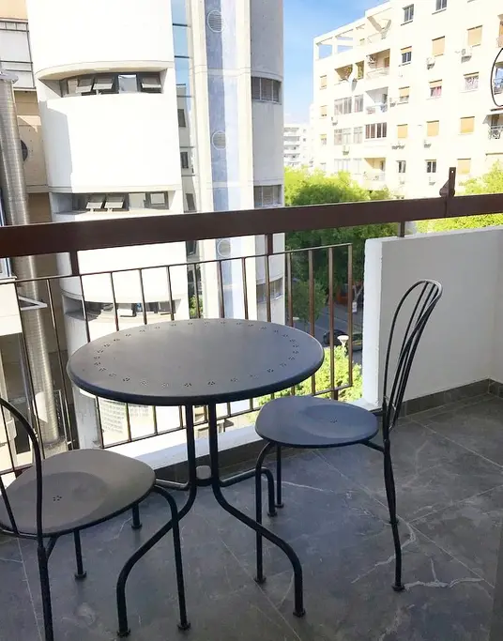

**Ayia Napa**

* Constantinos Great Beach Hotel: $182 <https://www.travelocity.com/Larnaca-Hotels-Constantinos-The-Great-Beach-Hotel.h8804774.Hotel-Information?chkin=3%2F29%2F2019&chkout=3%2F31%2F2019&rm1=a2&amenities=30&sort=recommended&hwrqCacheKey=261c3acb-556c-429f-9a77-19a15c8c641eHWRQ1547835906896&cancellable=false&regionId=6051504&vip=false&c=b5396101-15d2-4cc4-8c27-82ef2205aff4&&exp_dp=109.39&exp_ts=1547835907197&exp_curr=USD&swpToggleOn=false&exp_pg=HSR>
* Pavlov Napa Beach Hotel: $180 for two nights <https://www.travelocity.com/Larnaca-Hotels-Pavlo-Napa-Beach-Hotel.h1099226.Hotel-Information?chkin=3%2F29%2F2019&chkout=3%2F31%2F2019&rm1=a2&amenities=30&sort=recommended&hwrqCacheKey=261c3acb-556c-429f-9a77-19a15c8c641eHWRQ1547835906896&cancellable=false&regionId=6051504&vip=false&c=b5396101-15d2-4cc4-8c27-82ef2205aff4&&exp_dp=82.11&exp_ts=1547835907198&exp_curr=USD&swpToggleOn=false&exp_pg=HSR>

**Car Rental**

* Only takes between 2 - 3 hours to drive from one side of the island to the other

<http://stevenscarrentals.com/>

Itinerary

|  |  |
| --- | --- |
| **Date** | **Activities** |
| Sunday, March 24 | Flight arrives in Larnaca @ 6:30pm, rent car, check into an Airbnb & get dinner nearby |
| Monday,  March 25 | Grab breakfast at nearby bakery, Hala Sultan Tekke mosque (20 min drive), lunch, visit Saint Lazarus Church & explore Ermou square, sunset at Finikoudes beach/Larnaca fort/marina, dinner |
| Tuesday,  March 26 | Check out of Larnaca Airbnb, check into Nicosia Airbnb   * Walking tour of old Nicosia * Shacolas Tower Museum and Observatory * Ledra Street |
| Wednesday, March 27 | Check out of Nicosia Airbnb, check into Paphos airbnb   * Petra tou Tomiuo (aka Aphrodite’s Rock) * Parasailing (Xtreme Sports) * Tour of Vouni Panayia Winery (45 min drive) |
| Thursday, March 28 | * Tombs of the Kings * Agios Neophytos Monastery * Sunset at Coral Bay   + 15 minute drive between each |
| Friday, March 29 | Check out of Paphos airbnb, check into Ayia Napa resort   * CAM’S BDAY!!! |
| Saturday, March 30 | * Sea caves * Beach day - Nissi, Makronissos, Konnos Bay |
| Sunday, March 31 | Check out of Ayia Napa airbnb, return car, get to Larnaca airport at at 1pm |

Restaurants

|  |  |
| --- | --- |
| Larnaca | Maqam Al-Sultan Restaurant |
| Nicosia | Pyxida Fish Tavern |
| Paphos | Seven St George's Tavern |
| Ayia Napa | Zaatar Lebanese & Syrian Restaurant |

Payments:

[**Larnaca**](https://www.airbnb.com/rooms/22912870?s=51)**:** $175.77

[**Paphos**](https://www.airbnb.com/rooms/24701492?s=51): $141.14

[**Nicosia:**](https://www.airbnb.com/rooms/27817849?s=51)$90

[**Ayia Napa:**](https://www.travelocity.com/trips/6c5cd3bf-78a8-4113-92cc-42b111d550c8?useCache=false) $232.14

Total: $639.05 / $213.02 per person

**Car Rental:**

Company: Budget

Pick-Up: Sunday, March 24th at 7:30 pm, at airport

Drop-Off: Sunday, March 31st at 1:00 pm, at airport

Confirmation #: 03380627US5

Budget Contact Number: +357-24643293

**Airbnb Contact Info:**

**Larnaca (March 24th - 26th)**

Address: Constantinou Kalogera SOHO City Apartments, apt 302, Larnaca, Larnaca, Cyprus

Check-In: at 2:00 pm, key is in lock box, check-out at 12:00 pm

Host: Constantinos, phone: +357-99654480

Confirmation Code: HMSXT43S8S

**Nicosia (March 26th - 27th)**

Address: No. 12 Naxou Street Flat 301, Nicosia, - 1070, Cyprus

Check-In: at 2:00 pm, check-out at 12:00 pm (instructions not available yet)

Host: Natalie, phone: :+357-99170828

Confirmation Code: HMNJDJ2MDM

**Paphos (March 27th - March 29th)**

Address: not given yet

Check-In: at 2:00 pm, check-out at 12:00 pm (instructions not available yet)

Host: Andreas, phone: +357-99489883

Confirmation Code: HM2QHP48XH

**Ayia Napa (March 29th - March 31st)**

Address: Melpo Antia Luxury Apartments and Suites, Nissi Ave 4, Ayia Napa 5330, Cyprus

Contact: +357 23 721921

Check-In: